***Name: Siddhant Mundhe***

***DATA ENGINEERING BATCH 1***

***DAY 1 ASSIGNMENT***

**DATA WAREHOUSING**

* A data warehouse is a centralized and organized repository for all your business data, making it easier for you to analyze and make informed decisions.
* Imagine you have a large store, and every day you collect a lot of information about the products you sell, the customers who buy them, and the transactions that take place. Now, if you want to analyze this data to make better business decisions, you might face a challenge. The data is scattered across different systems, and it's not easy to quickly see the big picture.  
  This is where a data warehouse comes in. A data warehouse is like a super-organized storage space for all your data. It's a centralized location where you gather, store, and manage all the information from various sources in your business. Instead of searching through different databases and systems, you can go to the data warehouse to get a comprehensive view of your business data.
* **FEATURES OF DATA WAREHOUSING:**

1. Subject-oriented:Think of it like organizing data based on specific subjects or topics, rather than how it's stored in different systems. For example, all data related to sales, customers, or products is grouped together, making it simpler to understand and analyze specific areas of interest.
2. Integrated: Integration means bringing together information from various sources and making it work seamlessly.
3. Time-Variant: This means the data warehouse keeps track of how things change over time. For example, you can see how sales, customer preferences, or inventory levels evolve over weeks, months, or years.
4. NonVolatile: This means the data warehouse keeps track of how things change over time. For example, you can see how sales, customer preferences, or inventory levels evolve over weeks, months, or years.

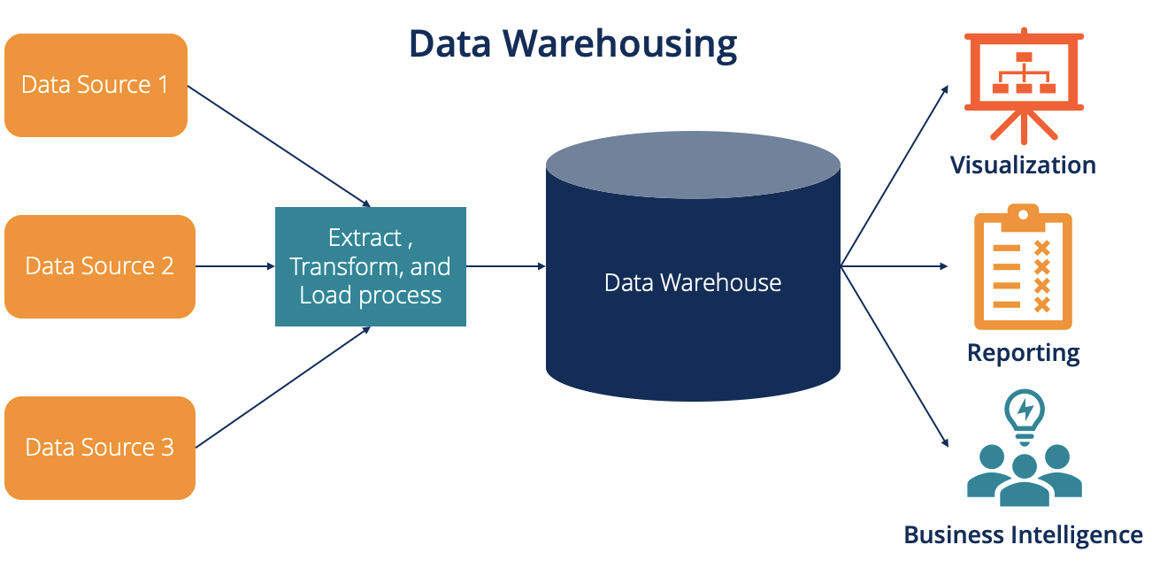**Fig. Data Warehouse**